**How Prada and Louis Vuitton associate uniquely with craftsmanship**

Both brands have an unrelenting dedication to creating exceptional products—giving all needed attention to their craftsmanship and product design. Aside from that, every product they make is handmade and has utmost care as one of its primary ingredients. Though they now operate on a large scale, they both maintain the feeling that a small company will have towards making it work admirably.

The high level of craftsmanship it puts into the making of its product is where **Louis Vuitton** gets substance for its value. The quality of materials is also significant as the brand only uses quality materials in its production. When you consider the heritage, creativity, craftsmanship, and other things regarding the Louis Vuitton product, all you’ll see is an epitome of excellence in quality. Its products offer beauty, sturdiness, uniqueness, class, and several unspoken exceptional attributes. Louis Vuitton’s products are solid, and they usually come through endurance tests before they get pushed out into the market. They also come through the fire and get made from waterproof materials. Most of LV’s designs have trademark signatures on them to maintain exclusivity. In general, value is not a compromise.

**Let’s take the example of handbags :** 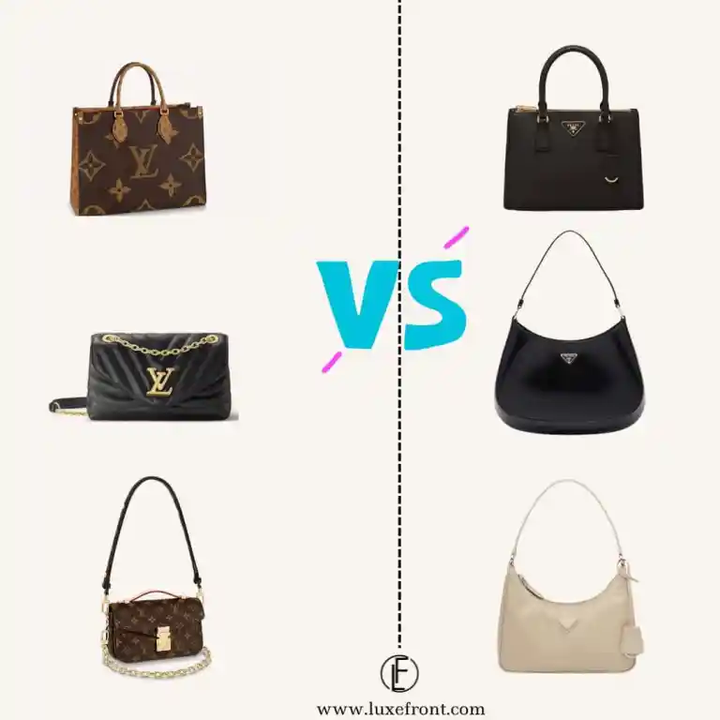

**Louis Vuitton** is best known for its impeccable

craftsmanship, luxurious quality, and of course,

the signature brown and cream checkered

monogram pattern. LV handbags are also extremely

versatile, offering options for just about any occasion

and style. While their handbags, satchels, and totes

are made for everyday and special event wear,

their luggage provides a stylish way to travel—

something that sets the designer apart from others.

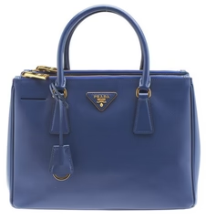

**Prada** handbags are known for their elegant and

timeless simplicity, and have come to be a symbol of

style and grace. Whether your style is classic, edgy, or

extravagant, a statement Prada bag is sure to be a show

-stopper. Prada is among the most counterfeited

designer bags in the world, due to their sleek,

minimalistic appearance and simple design. Despite

their modest simplicity, Prada bags are far from boring

—their classic charm has been highly sought after by

those who want to portray a timeless elegance and

sophistication.